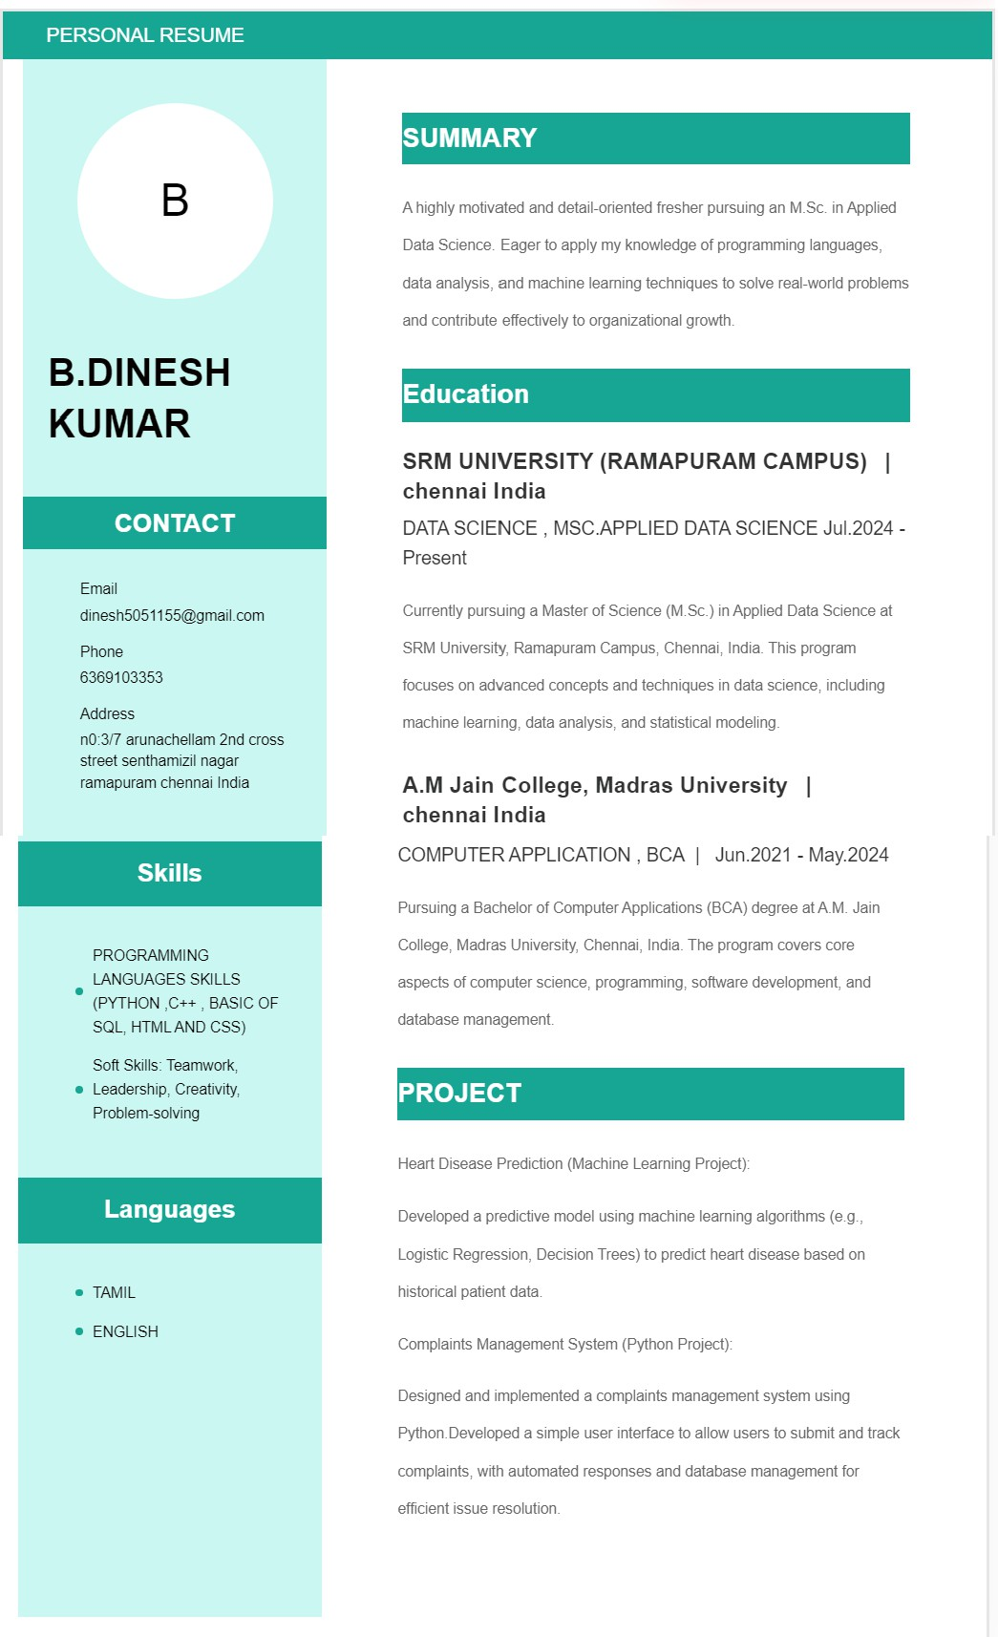

**INTERNSHIP**

JUNE 11.06.2025 - JUNE 25.06.2025

**TOP TECH DEVELOPER**

DATA ANALYSTICS

(TRAINEE)